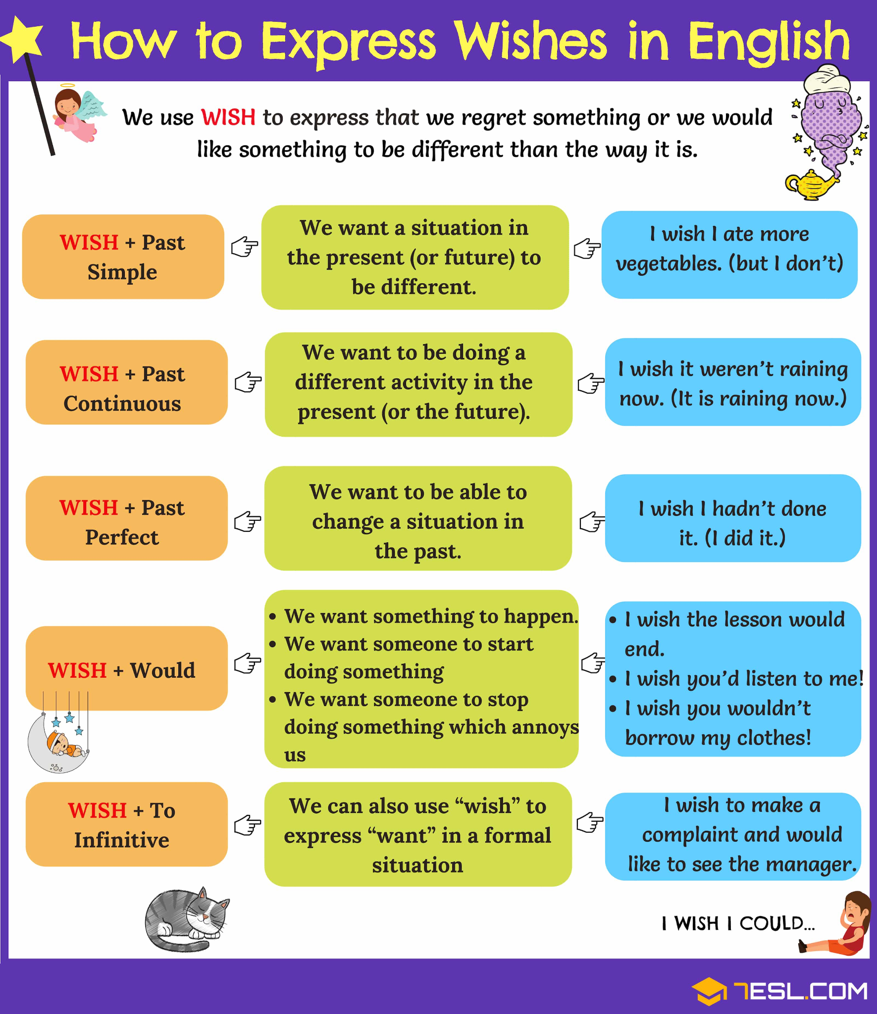

**Task 1. Choose the most appropriate answer.**

1. He likes to swim. He wishes he  near the sea.

lives lived had lived would live

2. It's cold today. I wish it  warmer.

is has been were had been

3. I wish I  the answer, but I don't.

know knew had known would know

4. She wishes she  blue eyes.

has had had had would have

5. She wishes she  a movie star.

is were will be would be

6. I have to work on Sunday. I wish I  have to work on Sunday.

don't didn't won't wouldn't

7. I wish you  borrow my things without permission.

don't won't shouldn't wouldn't

8. He wishes he  buy a new car.

could might should would

9. She misses him. She wishes he  her a letter.

has sent will send would send would have sent

10. I wish I  help you.

can could will would

**Task 2. Rewrite the following sentences using Past Simple or Past Perfect in ‘I wish’ construction.**

1. Sophia does not speak German.

Sophia wishes__________

1. I didn’t meet my friends at the cinema.

I wish__________

1. Olivia broke her mirror.

Olivia wishes_____________

1. I feel confused all the time.

I wish_______________

1. I didn’t leave a message to him.

I wish______________

1. My mother is angry with me.

I wish________________-

1. Lucas fought with his best friend.

Lucas wishes____________

1. William didn’t prepare for the test.

William wishes_______________

9. I am not as tall as you are.

I wish___________.

10. My friend James lives far from me.

I wish_______________.

**Task 3.**

1. **Complete the sentence with the correct tense of the verb in brackets.**

1. We always have to take the bus home. I wish we (not live) so far from the city centre.

2. We are completely soaked. I wish we (bring) the umbrella.

3. He is always whistling. I wish he (not do) that all the time.

4. We are having a wonderful holiday on the beach. I wish you (be) here.

5. This computer is useless. I wish my parents (choose) a better one when they bought it.

6. She's got a new job but she feels bored. She wishes her boss (give) her more responsibility.

7. He's sorry he missed the wedding ceremony. He wishes he (go) there.

8. I wish my neighbours (not make) so much noise. I can hardly sleep at night.

9. Citizens wish their leaders (start) doing something to improve the economic situation.

10. They have lots of money. Even so, they wished they (have) more and more.

1. **Write a sentence using "wish" or “if only”**

1. I ate too much and now I have stomachache.

2. His parents would like him to look after himself.

3. I can't smoke anywhere now. The anti-smoking law is so restrictive!

If only

4. It's a pity we don't own a boat, I love sailing.

5. My pupils keep talking in class all the time and I can't handle it.

6. Visiting the museum was interesting but it would have been nicer to go to the beach.

7. Next Christmas I would like to stay at home for a change

next Christmas.

8. He never brings me flowers on our anniversary.

9. I failed all my exams. I should have studied harder.

If only

10. I don't like being so tall.

Task.

Read the article.

Write down unfamiliar words.

Answer the questions after the article in a written form. DON’T use the sentences from the article.

Look up the following words and phrases in the dictionary. Check the pronunciation if you are not sure.

interchangeably

fulfil requirements

procedure

defect

final checkpoint

manual

validation

complaint

quality awareness

competitiveness

occurrence

encompass

document

deliverable

introduce

distinct

**Quality control**

Quality should be a habit for every organization, no matter the industry. If you deliver products or services, the quality level is something you should constantly monitor. The major components of quality management are Quality Assurance and Quality Control. These terms are often confused with one another and hence, used interchangeably. However, there are a number of distinctions between the two.

## **What is Quality Control**

Quality Control (QC) is a part of quality management. However, QC is focused on fulfilling quality requirements. Broadly speaking, it is the inspection aspect of quality management. QC is a strategy of detection – it uses operational techniques and procedures to identify defects in products and services and ensure that the project deliverables meet the desired quality standards. The Quality Control process detects bugs and defects in the product and reports them so that they can be fixed. If a problem is identified, it must be resolved before the product is delivered to customers. Summing up, Quality Control is the final checkpoint before the delivery.

Examples of Quality Control activities: inspection, measurements, manual and automated testing, verification, and validation.

### **Why you should implement QC in software development**

Quality Control reduces costs. Thanks to QC, customer needs are better satisfied - when you combine QC activities with requirements engineering processes, you get minimal consumer complaints after the software is delivered. Quality Control reveals common errors so they can be avoided in the future. It develops and promotes quality awareness among employees, which is a great help in attaining the required quality level of the product. Quality Control increases the competitiveness of the company as it delivers better quality software and meets the requirements of the customer. Finally, thanks to QC, you can introduce changes to the projects and plans that follow.

**Characteristics**

**reactive**

* Quality Control is **reactive**. It identifies defects after their occurrence. The strategy focuses on testing products once they are developed to ensure all the safety measures have been met.

**product**

* Quality Control is all about the **product** as it focuses on the quality of the final software or app. Quality Control encompasses achieving and maintaining product quality, process, and service through batch monitoring, product sampling, validation, inspection, and testing.

### 

### **Implementation stage**

* Quality Control activities verify specific elements of the product, post-development and before distribution. They confirm that the product meets the predefined standards.

### 

### **the parts**

* Quality Control measures the outputs of the system, testing each part of the product once ready.

### 

### **verification role**

* Quality Control comprises product verification after development but prior to distribution. The main goal is to find as many bugs as possible.

### **individuals**

* Quality Control is more the primary responsibility of a specific part of the team. Their duties include following the standard procedures for product testing. They also document their findings using standardized procedures for product validation and product testing.

## 

## **Conclusions**

Quality Control follows these procedures to ensure the deliverable is of the required quality. QC is a distinct part of the software testing cycle.

**Answer the questions after the article in a written form. DON’T use the sentences from the article.**

1. Why is Quality Control essential?
2. What does QC use to detect defects?
3. Why is QC so vital for software development?
4. What does QC reveal?
5. What does QC help to increase? Why?